**Spend a weekend at Camp Jubilee with Canadian Parents for French Tri-Cities Chapter**

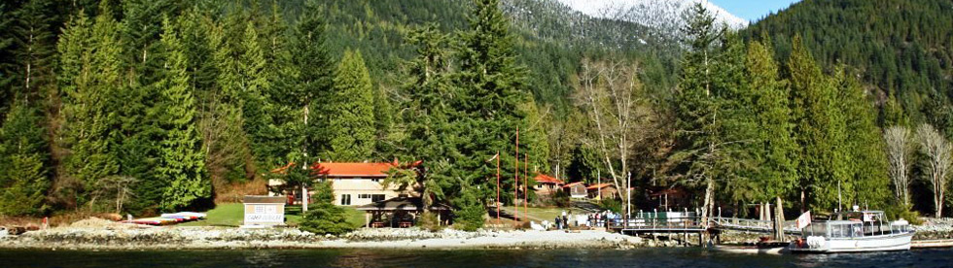

Camp familiale en français

SUMMER WEEKEND EDITION

AUGUST 28 -30, 2015

Camp Jubilee

Your adventure begins aboard of Camp Jubilee’s certified passenger vessels for a short 30 minute boat ride from Deep Cove in North Vancouver BC. Camp Jubilee sits on 128 acres of Indian Arm waterfront and combines modern, comfortable accommodations, great food and spectacular scenery – all at affordable prices.

Amenities include cabin style accommodations, a variety of program areas, oceanfront BBQ pavilion, outdoor amphitheater and much more.

At Camp Jubilee our goal is to make your stay as enjoyable as possible – an experience you’ll always remember!

Join us for a fun-filled summer weekend, where parents and children relax, have fun, and get ready for another year of French language school. We are offering two excellent packages from which to choose: Extreme package, which includes high rope, rock climbing, voyageur canoeing and nature hike; and Adventure package, which includes low ropes, voyageur canoeing, marine/beach study and archery. For the extreme package, children must be 12 or older.

• All meals provided

• Stay in a rustic family cabins that sleep 10

• Pour les enfants, des activités en français

• Families enjoy a summer-camp experience together— eating meals in the great outdoors, hiking, exploring the camp area, and evening campfire fun

• Optional programming for adults on local French resources and homework help

• Lots of free-time to enjoy!



Camp Jubilee Application Form August 28 – 30, 2015

|  |  |  |
| --- | --- | --- |
| PRIMARY CAMPER INFORMATION | | |
| Parent or Guardian Name (must be camping) | | |
| Phone | Current Address | |
| City | Province | Postal Code |
| CPF member: yes ______ no ______ | Health condition, food restrictions, food allergies: If yes, please explain | |
| CPF members receive discounted rates |

|  |  |
| --- | --- |
| OTHER CAMPERS ATTENDING | |
| NAME | AGE GROUP: ADULT/CHILD (INCLUDE AGE) |
|  |  |
|  |  |
|  |  |
|  |  |
|  |  |

|  |  |  |  |
| --- | --- | --- | --- |
| EMERGENCY CONTACT | | | |
| Name of a person not camping with you | | | |
| Address | | I authorize the release of children to this person in an emergency: __________ | |
| Phone | Alternate phone | | Relationship: |

|  |  |
| --- | --- |
| CAMPING FEES | |
| Number of campers: _____ x $180 Adventure package for CPF members  _____ x $200 Extreme package for CPF members  _____ x $90 for children 3 and under  _____ x $205 Adventure package for non CPF members  _____ x $225 Extreme package for non CPF members | Total: |
| CPF family membership (optional) x $25 | Total: |
| Cabins sleep 10; therefore families must share. If there is a family that you would like to share with, please indicate family name here: | |

|  |  |
| --- | --- |
| NOTICES TO BE INITIALED BY ADULT PRIMARY CAMPER | |
| |  | | --- | | I understand that no alcohol or pets are permitted at Family Camp | |  |
| |  | | --- | | I understand that adults must remain on site during all period when children are unsupervised | |  |
| I understand that programming is provided for children entering grades 1 - 9. Parents are responsible for supervision of children while not attending programming. |  |

|  |
| --- |
| SIGNATURE OF PRIMARY CAMPER |
| |  | | --- | | I the undersigned, permit my family to participate in the full range of camp activities and authorize the Camp Director, in the event of an accident or illness affecting any of the above, to authorize on my/our behalf all procedures, including admission to the hospital and necessary treatment therein, as they may deem essential for the care and well-being of my/our family. I agree to accept financial responsibility in excess of the benefits allowed by Provincial Health and/or Medical Insurance. | |
| SIGNATURE: |

|  |
| --- |
| REGISTRATION OPTIONS |
| |  | | --- | | **Email** completed form to: tricitiescpf@gmail.com or **Mail to:** CPF Tri-Cities Chapter, Suite 2 – 300 Maude Road, Port Moody, BC V3H 2X6  **Cheque** Payable to Tri-Cities CPF  Registration deadline: June 15, 2014 | |